After six days of competition, the Chinese competitors showed the best results in the history of China's participation in WorldSkills. The team won 16 gold medals in the areas of "work on CNC machines", "Welding technologies", "Polymechanics and automation", "Architectural stone processing", "Repair and maintenance of passenger cars", etc. Also, masters from China won 14 silver medals in the competence "Information cable networks", "mechatronics", "maintenance of aviation equipment", "Plumbing and heating", etc. and 5 bronze medals in the competence "Industrial mechanics and installation", "Cookery", "Production of products from polymer materials", "Baking" and "Industrial mechanics and installation". Chinese contestants also received 17 medallions "for professionalism" in the areas of "Software solutions for business", "Printing technologies in the press", "tiling", etc.

At the closing ceremony of the championship in Kazan, the flag of the WorldSkills movement was solemnly handed over to representatives of the Chinese city of Shanghai, where the 46th WorldSkills world championship will be held in 2021. In addition, the Shanghai delegation presented to the audience an artistic performance on the theme "Charming China and lively Shanghai".

* 

**Yuhui Zheng**

**Gold  
Polymechanics and Automation**

* 

**Guofa Wei**

**Silver  
Information Network Cabling**

* 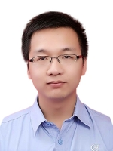

**Chenxi Peng**

**Gold  
Manufacturing Team Challenge**

* 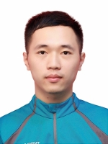

**Xinpeng Chen**

**Gold  
Manufacturing Team Challenge**

* 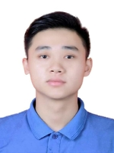

**Xiangbo Zeng**

**Gold  
Manufacturing Team Challenge**

* 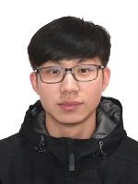

**Chenghao Yin**

**Silver  
Mechatronics**

* 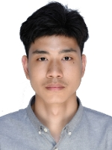

**Hu Xie**

**Silver  
Mechatronics**

* 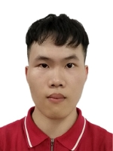

**Xiaocheng Huang**

**Gold  
CNC Turning**

* 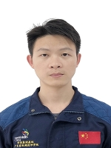

**Zhenji Tian**

**Gold  
CNC Milling**

* 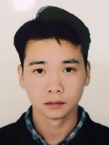

**Quan Zheng**

**Gold  
Architectural Stonemasonry**

* 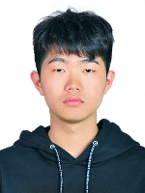

**Fubo Zhao**

**Gold  
Welding**

* 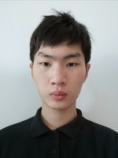

**Aomen Xu**

**Gold  
Autobody Repair**

* 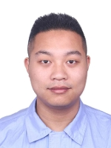

**Zhongsheng Ye**

**Silver  
Aircraft Maintenance**

* 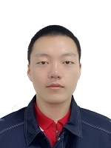

**Yingzheng Yang**

**Silver  
Plumbing and Heating**

* 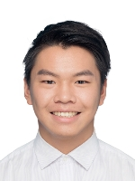

**Pan Liang**

**Gold  
Electronics**

* 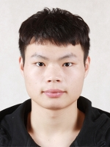

**Xingxing Xiao**

**Gold  
Electrical Installations**

* 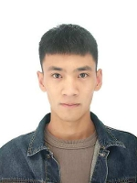

**Jiangtao He**

**Bronze  
Industrial Control**

* 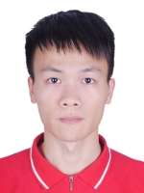

**Zifeng Chen**

**Gold  
Bricklaying**

* 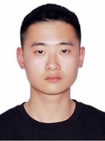

**Yuzhou Gao**

**Silver  
Plastering and Drywall Systems**

* 

**Gengjun Hu**

**Gold  
Mobile Robotics**

* 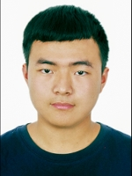

**Qiyuan Zheng**

**Gold  
Mobile Robotics**

* 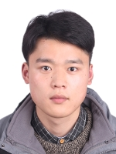

**Jinqing Wu**

**Silver  
Cabinetmaking**

* 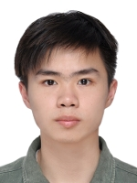

**Qiliang Chen**

**Silver  
Jewellery**

* 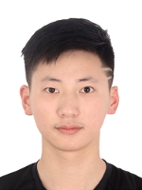

**Yiwei Lu**

**Gold  
Floristry**

* 

**Dan Shi**

**Gold  
Hairdressing**

* 

**Zhenqin Li**

**Silver  
Beauty Therapy**

* 

**Caiyun Wen**

**Gold  
Fashion Technology**

* 

**Lingyi Zhong**

**Silver  
Pâtisserie and Confectionery**

* 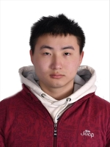

**Zhen Wang**

**Silver  
Automobile Technology**

* 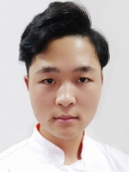

**Yongkang Lin**

**Bronze  
Cooking**

* 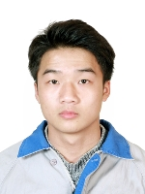

**Hao Liu**

**Silver  
Construction Metal Work**

* 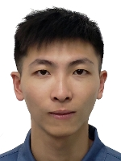

**Senrui Lu**

**Bronze  
Plastic Die Engineering**

* 

**Liping Luo**

**Silver  
Visual Merchandising**

* 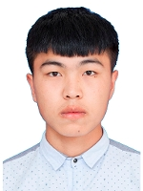

**Junhui Chen**

**Gold  
Concrete Construction Work**

* 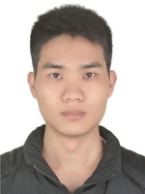

**Junhong Li**

**Gold  
Concrete Construction Work**

* 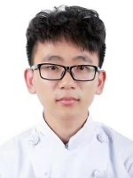

**Ziyang Zhang**

**Bronze  
Bakery**

* 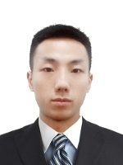

**Weiyu Zhang**

**Bronze  
Industrial Mechanic Millwright**

* 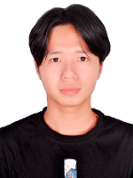

**Dingjun He**

**Silver  
3D Digital Game Art**

* 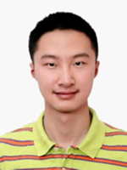

**Zitong Xiao**

**Silver  
Cyber Security**

* 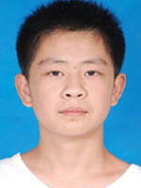

**Zhutian Feng**

**Silver  
Cyber Security**

* 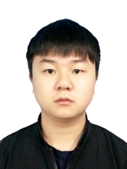

**Lufeng Zeng**

**Gold  
Water Technology**